Lesson Plan
Multiple Intelligences: How Are You Smart?

The lesson was developed after thinking about multiple intelligences in student teaching seminar and after the workshop with Debbie Flaks. She was able to provide me with resources after I emailed her and expressed interest in this type of lesson.

Objectives:
1) Students will realize that people are intelligent in different ways. Everyone has all of the SMARTs (intelligences).
2) Students will recognize the different types of SMARTs (intelligences).
3) Students will role play different types of SMARTs.
4) Identify how students use their SMARTs in their daily experiences.
5) Students will begin to think about how to develop their SMARTs.

Materials:
Index Cards with role play scenarios, SMARTs pie graph handouts, “How are you SMART?” handouts (see below)

Procedure:
1) Introduce rhetorical question “How smart are you?” Then, rephrase as “How are you smart? Discuss what’s the difference?” (Whole class- on rug) (1.6.3. Listen to others)
2) Introduce each type of SMART by going over pie graph handout. Share examples or personal connections.
3) Introduce role plays.
4) Model a role play, with a student volunteer.
5) Put students in pairs or 3’s for role plays, and hand each group an index card with the scenario. To make relevant to class, the scenarios should deal with social situations familiar to students, or involving academic content in the classroom. (i.e. role play a character in a book the class is reading in class, or role play a recess situation.)
6) Present role plays to class. (1.6.3. Participate in small and large group discussions and presentations.)
7) Follow-up/ assessment: Complete “How are you smart?” handout.
8) Differentiation Ideas: Group students by which scenarios they might be most comfortable role playing. If a student has shown to be exemplary at sports, group him/her in a role play about “Body SMARTs” .

The scenarios used for this lesson (the scenarios can and should be different depending on the students and classroom).

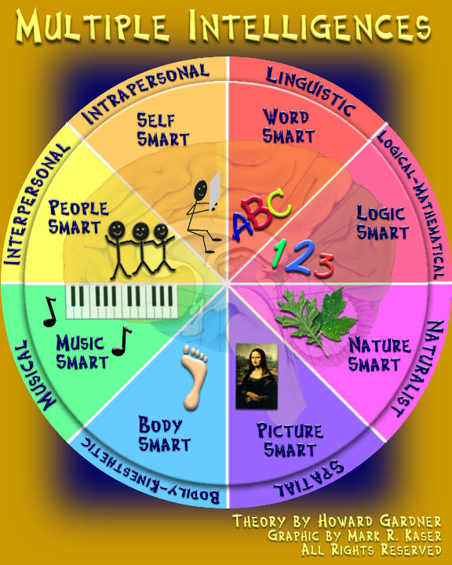

NAME ___________________________ NUMBER _____

How are you SMART?
A. Think of an example from your own experience when you used each kind of SMART. Please write it below.

Type of Smart | Example from your own experience | An Illustration
**BODY SMART

**LOGIC SMART

**MUSIC SMART

**PEOPLE SMART

**PICTURE SMART

**SELF SMART

**WORD SMART

B. Which SMART do you think you use the most? ___________________
C. Which SMART do you enjoy the most? ____________________
D. Which SMART would you like to strengthen? ___________________
E. Think of one way you might strengthen the SMART you wrote for D.
________________________________________________________________

